Back Pain?

.

Stage 1: A stiff spinal segment Healthy disc Stiff disc
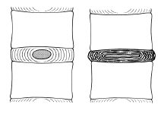
Discs in a healthy spine are full of fluid. Long term disc compression leads to decreasing fluid content and causes the disc to stiffen. This stiffness results in a dryer, flatter disc (see illustration). If this is not addressed, adjacent segments can also begin to stiffen. A stiff spinal segment causes vague, non-specific lower back pain.

Stage 2: Facet joint arthropathy
As the disc dries, flattens and begins to lose height, the two facet joints sitting behind the disc begin to rub together. Initially, this causes inflammation and pain around the facet joint surface. Over time, arthritic change develops as the cartilage covering the facet joint surfaces grinds away. This results in a knife like pain localised at a particular point in the spine.

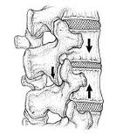
This illustration of a spinal segment shows the middle disc height narrowed and demonstrates how the facet joint surfaces grind against one another resulting in facet joint arthropathy (arthritis) and facet joint pain.

Stage 3: The acute locked back
When our spine moves the spinal muscles must co-ordinate to support each spinal segment. Vertebrae must be held apart by plump discs full of fluid so the facet joints can glide past each other without grinding. Continued loss of disc height (Stage 1) results in an unstable segment. If this occurs, your body realises movement is uncontrolled and reacts with segmental spasm to protect the joint. This spasm is immediate and immobilising.

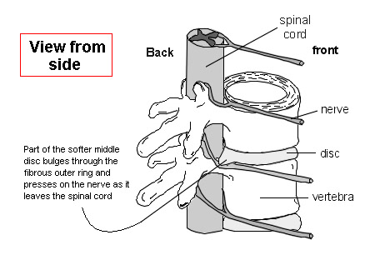
Stage 4: The prolapsed disc
If disc degeneration progresses, the fluid held inside the disc begins to push on the outer disc wall. This results in increased load and pressure on the disc wall, and can cause it to bulge/prolapse outward. If it bulges far enough it can press on the nerve that passes. The result is sciatic pain (leg pain) which feels like a knife tearing down the leg.

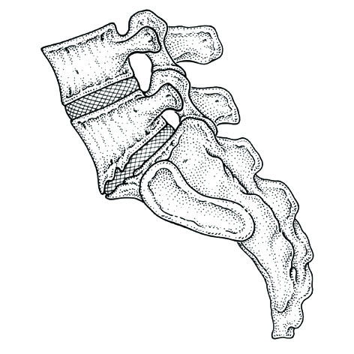
Stage 5: The unstable spinal segment
After disc prolapse there is further loss of disc height and therefore increased movement at that segmental level. Radiographic change (see illustration) demonstrates the progression from Stage 3 to Stage 5. The changes that appear on X-ray show your body has been trying to stabilise the segment with excessive bony growth because your muscles are incapable of the task. This results in multiple episodes with increasing frequency of ‘immobising spasm’ as your body tries to protect the surrounding tissue.

With expert care pain caused by degeneration of the spine can be eliminated. Please contact us so we can help you learn how to look after your back.

