The BackBlock to decompress and straighten both ends of the spine
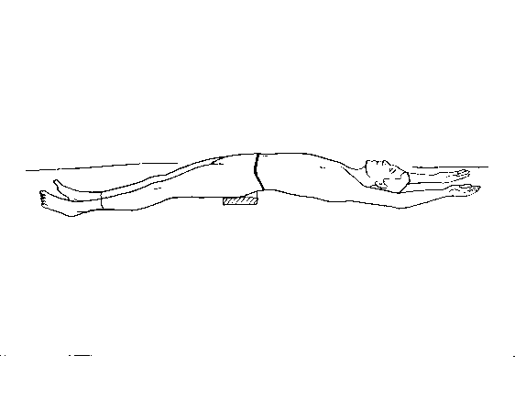
1

Lying on your back with your knees bent, lift your bottom off the floor by rolling up your spine, one cog at a time, until you are taking all your weight on the prominent vertebrae at the base of your neck (see strengthening ex# 1) and before folding down again place the back block on its flattest side under your sacrum. Take care to get the BB in exactly the right position, moving it around minutely, to where it feels most comfortable. Gradually push one heel out across the floor (do not lift the leg), then the other, until you are fully draped backwards over the block. Lie passively there, letting gravity do all the work of pulling your segments apart as it presses the spine straighter. Allow your legs to roll out and let everything go. You will feel a pulling sensation inside at the base of your spine and at the front of your hips. Remember! The more you relax the more your spinal segments will separate. After 60 seconds, bend one knee up and then the other, lift your sacrum carefully (you can get a jink of pain at this point) and then go into knees rocking (see appease ex# 1) for 30 seconds. When your back no longer feels cast progress to ex’s 2 and 3. When your back is fully softened and relaxed do 15 reverse curl ups (see strengthening ex# 3). Repeat 3 times.
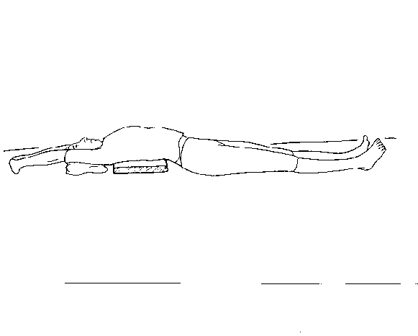
2

Position the back block longwise under your upper back, the top edge level with the base of your neck. Taking care not to knock the BB out of alignment, lie down over it, attempting to let your head go back to the floor. If this is impossible, you can use a small pillow temporarily. You will find it is much easier getting the head back when you take your arms over your head. Interlace your fingers and turn your palms away (arms as straight as possible). If it is too uncomfortable using the BB under the upper back, you can dispense with it completely for a bit and simply do “the dart”; lying flat on your back on the floor, fingers interlaced above the head and arms straight with the palms turned away, making your body as ‘long’ as possible – no back block involved.

