Injury and Recovery

Did you know…

- Literature reports between 25% and 45% of our population is experiencing significant musculoskeletal pain at any one time.
- 80% of us suffer at least one significant episode of Low Back Pain at some time in our lives.
- More than 10% of our population experience significant musculoskeletal pain every day.

If you have, suffered, or are suffering, pain and injury then you can rest assured you are not alone.
The good news is the vast majority of these painful problems are not permanent. They often better in less than three months and can be much improved in less than a week with great physiotherapy.

There are 3 possible causes of pain and injury.

Accumulative strain (the result of overuse of a particular structure or structures)

Non-accumulative strain (a one-off incident with involving enough force causes injury and pain)

More rarely, disease causing musculoskeletal pain (infection, chromosomal and genetic problems)
It is not commonly known that great physiotherapy can relieve the strain to the vast majority of musculoskeletal conditions in both the top two categories above, very quickly. You don’t have to wait for healing to occur to be able to be pain free and back to full function.
Accumulative strain is by far the greater cause of pain in the general population.
Often when the pain onset seems to occur suddenly it is actually a case of the ‘straw that broke the camel’s back’.

Common activities that produce accumulative strain that you might identify with:
- Turning your head to reverse the car (neck)
- Bending over to put on shoes (lower back)
- Bending over to pick up a heavy object such as a pot plant (lower back, shoulders, neck)
- Using a computer for many hours each day (neck, upper back, shoulders)
- Sitting for many hours each day (lower back, upper back, neck)
- Driving for many hours (lower back, upper back, neck)
- Repetitive tasks without many breaks and variation (painting, cleaning, manual work – shoulders, wrists, elbows, neck, lower back, mid back)
- Repetitive actions in sport ... and many more (basically, anything performed for long periods or repetitively will affect the body part being used)

The graph summarises:
'Optimal' Strain: with the blue (lower) area showing minimal strain on the body.
'Subclinical' Strain: that builds up over time, the maroon (middle) area, and not enough to require a conscious warning with the brain creating a pain signal.
'Clinical' Strain: shown by the yellow (top) area, where the brain's guarding / protection and warning signal creating pain turns into a vicious cycle that does not quickly settle by itself. The point where the Strain Line hits the Pain Threshold is the point where the 'straw breaks the camel's back'.

Nepean Physio Clinic Model of Musculoskeletal Health

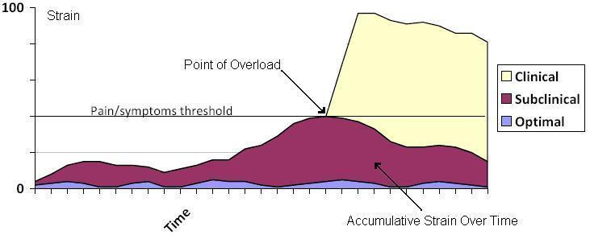
Remember, it’s not the activity that leads to accumulative strain; it’s the way the activity is performed…..with repetitive, poor control.

The graph below describes the typical results achieve with great physiotherapy for the vast majority of conditions (where Rx = treatment). Each improvement made with treatment is represented by a downward slope of the graph. The treatments achieve a pain-free state in three sessions. If the results are not coming this quickly we may not be the right practitioners for the job! In these cases we will refer on.

Nepean Physio Clinic Musculoskeletal Recovery Model
