Wind Up
Many people are aware that a dysfunction in the muscles, joints, bones or nervous system can lead to injury within the human body. However it is not well publicized that thoughts, emotions and behaviors can also lead directly to injury and pain within the body. When we recognise the primary cause to a condition can be these factors we have the chance to address them.

The concept of “wind up” occurs in the body when there is too much tension (electrical-impulse activity) within the neural system of the brain & spinal cord. This wind up can be likened to the tension in a spring. There is an optimal range, above which there is an increase in stress which can lead to overload & dysfunction. Too much wind-up can be the primary cause of a problem!

How can we recognise Wind-Up?
Activities which cause this increase in neural signals arise from different areas within the brain and body:
Thoughts ⇒ Hyper-vigilance, unhelpful beliefs, mismatching ideas, unhelpful expectation, unconfident of what the problem is and how to fix it, memory of pain
Feelings ⇒ Frustration, stress, worry, anxiety, fear, depression
Actions ⇒ Self massage, excessive joint cracking, jittery movements, overdoing it, excessive stretching, excessive rib-cage breathing
Muscles ⇒ Tight, ache, spasm
Joints ⇒ Stiff, clicking, cracking, giving way
Nerves ⇒ Pins/needles, shooting pain, burning sensation
Organ Conditions ⇒ Immunological, illness; endocrinological, hormonal

Dysfunction of each of these parts of the system results in negative signals telling the brain of an 'unhappy state':

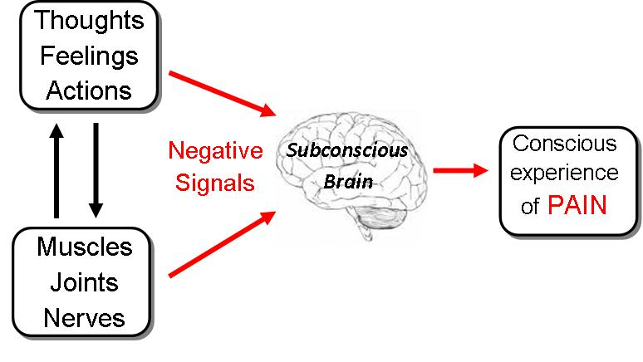

The previous diagram shows the interactions between the mental & physical systems of the body and how these influence the brain & pain processing. For example an increase in mental stress from anxiety can lead to an increase in muscle tension around a body part (the neck-shoulder muscles or low back muscles) however another example maybe anxiety and joint stiffness leading to an action of excessive behaviour; joint cracking.

Some of the most common categories for our mental state directly influencing the musculoskeletal system are negative attitudes, unhelpful behaviours, worries about a diagnosis, negative emotions, family stressors, work stress, relationship stress and financial compensation stress…to name a few.

When dysfunctional, these systems can transmit negative signals to the subconscious brain which contribute to “wind up”. Once this wind up is processed by the brain, and the tension in the 'spring' reaches a threshold, the final outcome is the brain creating pain & discomfort. This painful experience is our protective mechanism, an indicator that something needs to change.

What can be done about Wind-Up?
The negative signals to the brain can be turned off rapidly once the primary contributing factor, most significant, mental or physical factor is changed. Therefore in order to solve wind up within the system, the most significant negative signals from the mental & physical components must be addressed. Addressing these components, and making positive changes, is like releasing tension from the 'spring' and allows optimal function.

The results of solving the components that lead to wind-up, is that the brain does not receive as many negative (unhappy) signals and therefore there is less reason for the brain to create pain; as is seen in the diagram below:

