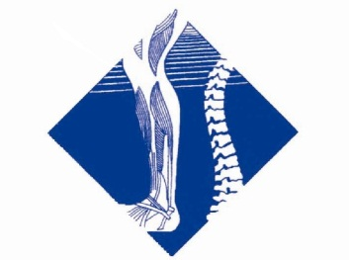
Joint “Cracking”- Frequently Asked Questions

Question: What is ‘cracking’ of a joint?
Well… it’s not the bone cracking as many might suggest.
The cracking sound (known as cavitation) is the result of a pressure change within the air-tight, fluid-filled joint. Gas is released…this is what makes the ‘crack’ or ‘popping’ noise. When a skilled musculoskeletal physiotherapist performs a ‘manipulative’ technique in the form of a [painless] quick, short, sharp movement of a joint, the aim is to normalise movement and send a signal to the brain that an effective ‘release’ has been achieved.
Practically speaking, the cracking sound is merely an indication that a pressure change occurred. The main aim of the manipulation technique is: the pressure change. This helps to achieve the desired result of freeing up a ‘locked’ or stiff joint. Freeing up a locked joint also results in decreasing pain.
Question: Is it safe to crack your own joints?
If your joint moves in normal ranges and ‘cracking’ occurs during this movement, then this is a natural change of pressure and is safe.
The key here is ‘normal range of movement’. Some people stretch past their normal range of movement and perform this excessive stretch repetitively for the sake of creating a cracking sensation or feeling good. This has a good chance of setting up long term problems with the joints.
Question: If my joints crack in their normal range…why do I need to see a physiotherapist?
A healthy joint will not have excessive pressure build up in the first place. When you move and a crack results this is an indication that you have been doing something to create excessive pressure and strain in the joints that crack.

If this is happening it is important you see your physiotherapist. If you

return to the activity that is excessively loading the joint that is cracking, then you are actually ignoring the problem. The cracking of your joints serves no purpose other than a temporary ‘feel good’ release and is even bad for you if this creates a habit that you rely on.
We highly recommend that you don’t use a cracking release of pressure after building up strain on your joints! The alternative is much more successful, productive and saves you time and money in the long run. Learn to develop the skills of correct postural position and muscle control to prevent accumulative strain developing in the first place!
At Nepean Physio Clinic we are experts at teaching you the best skills for ideal joint position and muscle control for your body. If you would like to experience this then contact us. We will explain how you can achieve optimal control.
Question: What is the effect of having musculoskeletal physiotherapist manipulate [crack] your joints?

When it is appropriate and applied to the right joint by a skillful technician, who performs the manipulation in the right direction, the patient can have a dramatic release of pressure and strain in and around joints that have suffered accumulative or traumatic injury. This is one of many effective methods we use of restoring full movement and eliminating pain. Your musculoskeletal physiotherapist will then help you understand how best to take care of the joint to avoid excessive pressure building up again.
These manipulation (cracking) techniques are not suited to all people and are certainly not suited to some specific conditions. This is not a problem, because we thoroughly assess the appropriateness of you and your condition if we feel a manipulative technique may be indicated. We also clearly explain every technique before performing them and we are very happy to avoid manipulation and use another gentler and effective techniques if this suits your preference.
Please ask us any questions about this topic. We are happy to help.

